Application Deadline
Friday, June 28th, 2019
@ 4:30 p.m. sharp

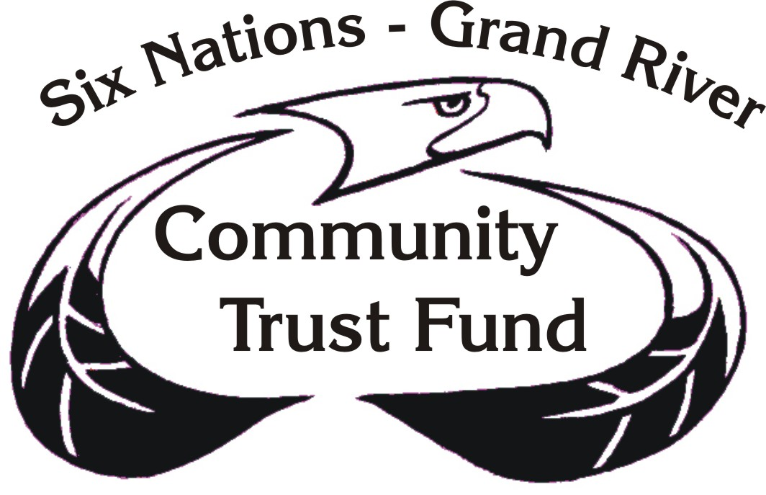

Application Form
2019

Dear Applicant:
The allocation for 2019 funding will range from $500,000 to $600,000.

Please submit only this application, SNCDT Application form 2019 package.

One (1) paper or electronic copy of your complete application is required. If more space is required to answer questions please attach a sheet and indicate the section and number of the question that you are answering. If using electronic version please type all information under the question in box provided.

ALL QUESTIONS MUST BE COMPLETED.
Please be mindful the appearance/completeness of your application is noted.
Please use checklist attached to the Handbook.

Also be informed that should your organization receive funding from the Six Nations Community Development Trust:
- A Financial Agreement must be signed prior to the release of any funding
- A 10% hold back of funding is placed on all Financial Agreements, payment
pending on approved final monitor.

All applications will be reviewed by the Trustees and if more information is required a letter will be sent. The request for further information in no way implies that your project has been approved. Failure to submit the requested information can result in your project not being approved for funding.

All applicants will be required to make a community presentation.

Projects where there are building renovations, land enhancements or infrastructure upgrades will need the following legal documentation included with application:
- proof of insurance including third party liability
- band council resolutions approving use of band owned land
- proof that any land or building is community owned

All submissions require a letter of acknowledgement from the board or advisory committee signed off by Board Secretary indicating they are fully aware of submission of project application to the Six Nations Community Development Trust.

The deadline date for applications is
June 28th, 2019 at 4:30 p.m.

Applications will be accepted at the Six Nations Community Development Trust Office, Oneida Business Park, 50 Generations Drive.
We will absolutely accept NO late applications after 4:30 p.m.

The Trust Coordinator is available to hold help sessions with applicants at a mutually convenient time. It is strongly recommended that first time applicants meet with the Trust Coordinator for application assistance. Please call and book a time that is mutually convenient for your schedule.

PART A – ORGANIZATION INFORMATION
 | Organization:
 | Mailing Address include Road Number (Blue flag number)
 | Town |  | Province/Territory |  |  | Postal Code
 | Telephone |  |  | Fax
 | Email |  |  | Website

Primary Contact Person
Band & Band Number
Telephone of Primary Contact

- Is your organization/group: Not for profit For-profit

- Will any member of board receive a wage or salary from this project?
No Yes → Please see exclusions on Page 1 and 2 of the Handbook – your application may not be eligible

- What is your organization’s mandate/mission?

- How long has your organization/group been in existence? ________

5. Describe your governance and management structure,

Describe Governance and Management Structure and insert organizations chart showing key positions.

List of Board Members
Board Members | Title

List Upcoming Board Meeting dates
Date/Time | Location

6. What activities have you provided or do you currently offer to the community? Provide details, including number of community members served.

7. How many staff members and volunteers belong to your organization?

 | Full-time | Part-time
Staff
Volunteers

8. Have you received SNCDT funding in the past?
No Yes
Please indicate the amount received to date: ___________

PART B - INFORMATION ABOUT YOUR PROJECT

If more space is required, please attach sheets to answer questions, be sure to indicate the question number.

1. Title of your project:

2. Where will this project take place?

3. Project Dates (must fall within January – December 2020)
Project Start Date: |  | End Date:

- Provide an executive summary of your project below: (250 words max.)

5. How will your project continue to operate after SNCDT funding is concluded?
Note: sustainability also applies to capital projects – i.e. staffing and maintenance of facilities, equipment, etc.

6. Have any research studies, surveys or questionnaires been referenced to determine the need(s) identified?

No Yes → Please identify and describe:

- The SNCDT provides funding for projects related to community development, cultural development, economic development, education and health. Briefly describe which funding categories apply to this proposal and how they will be addressed.

8. How many members of the Six Nations Community will actively participate in your project? (estimate how many will actively participate)
Children (0 – 12)
Youth (13 – 18)
Adults (19 - 64)
Seniors (65+)

9. How will you market your project to engage these community members?

10. Will your project create employment or economic growth for members of the Six Nations Community?

No Yes → Please describe below:

11. Will your project provide formal or traditional education or training for members of the Six Nations Community?

No Yes → Please describe below

12. Will your project in any way (other than formal training) improve the skills or increase the experience/expertise of members of the Six Nations Community?

No Yes → Please describe below

13. Will your project create any new physical infrastructure?

No Yes → Please identify below

14. Will your project support, link or connect with any other community initiatives?
No Yes → Identify below and attach letters of support
(3 max).

15. Please provide a detailed work plan

Purpose/Goal:  What do you intend to achieve? | Activities:  What are the main steps needed to achieve your project goals? | Responsibility:  Who will be responsible for each activity (in your organization or a partner organization)? | Timeline:  When will each task begin and when will you complete? | Results:  Your itemized list of expected accomplishments. | Evaluation Plan:  How will you evaluate the results of your activities? How will you know if your work is successful?

PART C – FINANCIAL REQUIREMENTS

16. Amount of funding requested: ____________

Please prioritize your expenditures by identifying the items of highest need.

 | Expense | Amount
1
2
3
4
5
6
7
8
9

17. attach last year’s financial statements
Financial Summary - Must be a reflection of your whole project costs, not just the amount being requested.
Please be sure to indicate all other funding being sought.
Item | Total Project Expense | Requested Funding SNCDT  (must match Request) | Other Sources of Funding |  | In-Kind Contributions  (given in non money form) |  | Source & Contact Person  Telephone & Email  Provide letters
Item | Total Project Expense | Requested Funding SNCDT  (must match Request) | Confirmed | Potential | Confirmed | Potential | Source & Contact Person  Telephone & Email  Provide letters
Salaries & Benefits
Program Costs
(Program-related expenses such as materials, resources, travel, promotion)
Administration
(Rent, insurance, office supplies, account & legal)
Capital
(Computers, office furniture, equipment, renovations, repairs)
Miscellaneous
(Please specify)

TOTAL
Note:
- Please include sponsorships, donations, grants and other financial assistance letters
- Include our own contributions to the cost of the initiative and those in-kind (given in the form of goods or services and not money) contributions of your donors and community partners
- Specify the source of confirmed and potential income (including in-kind contributions) and provide the name, phone # and e-mail
- Your total expenses should balance with the total of all income and contributions.
Summary of Quotes

All major capital costs over $2,500 and major contract work over $2,500 require 3 written estimates

Please summarize and prioritize your quotes in the tables below. Quotes must be of the same specs and descriptions. Attach quotes to application.

Quote for
# | Supplier |  | Cost | Brief Summary
1
2
3

Please explain why the first quote is your top choice.

Quote for
# | Supplier |  | Cost | Brief Summary
1
2
3

Please explain why the first quote is your top choice.

Quote for
# | Supplier |  | Cost | Brief Summary
1
2
3

Please explain why the first quote is your top choice.

PART D – PROJECT TEAM

List the names of each Project Team member, identify their position, roles and responsibilities and attach brief (one page max) profiles of their related experience, training and expertise (including Elders, Traditional People, and consultants).

If the Project Team will need to be hired (request for salary dollars), attach job descriptions, outline of hiring process to be completed, notice of competition and statements of qualifications. If the Project involves a purchase of services, attach service descriptions and tender document.

Team member | Position on team | Roles & responsibilities

Indicate your signing authorities for this project.

# | Name | Title
1
2
3

Please note Conflicts of Interest
Applicants must reveal any relationships or interests they have which could unfairly influence their proposal, negatively affect the outcome of a project or otherwise jeopardize the integrity and reputation of the Trust.

PART E – RELEASE OF INFORMATION

I/We declare that all the information that has been provided to Six Nations Community Development Trust is true and correct. I/We therefore authorize the Six Nations Community Development Trust to obtain and/or make inquiries as deemed necessary for the evaluation of my application.

and that , I/We authorize any person, corporation or agency having information or knowledge of my project to release such information to the Six Nations Community Development Trust or a Representative thereof;

and that , I/We authorize The Six Nations Community Development Trust to release information or knowledge of my project to any person, corporation or agency and media requiring such information;

For the Recipient:

Signing Authority 1 |  | Signing Authority 2
Printed Name |  | Printed Name

The deadline date for applications is
June 28th, 2019 @ 4:30 p.m.
We will absolutely accept no late applications after 4:30 p.m.

You must submit One (1) complete application.

Six Nations Community Development Trust
Oneida Business Park, 50 Generations Drive
Box 7, Suite 111, Ohsweken, ON N0A 1M0
Phone: 905-765-1236 • Fax: 905-765-2755
Email: sntrust@sninternet.com

